9.83: a) b) The kinetic energy of the stick is 0.784 J, and so the angular velocity is

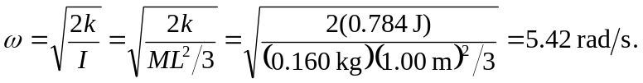

This result may also be found by using the algebraic form for the kinetic energy, 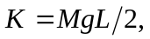from which 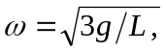 giving the same result. Note thatis independent of the mass.

